Pranavdeep A M – 22CSR148

DevOps
Day - 6

PROMETHEUS BASICS

Prometheus is an open-source system monitoring and alerting toolkit originally built at
SoundCloud. It is now a standalone opensource project. Prometheus joined the Cloud Native
Computing Foundation in 2016 as the second hosted project, after Kubernetes.

Features
1. A multi-dimensional data model with time series data identified by metric name and
key/value pairs
2. PromQL, a flexible query language to leverage this dimensionality
3. No reliance on distributed storage; single server nodes are autonomous
4. Time series collection happens via a pull model over HTTP
5. Pushing time series is supported via an intermediary gateway
6. Targets are discovered via service discovery or static configuration
7. Multiple modes of graphing and dashboarding support

Prometheus Installation: (Commands with output)
:
sudo useradd \
--system \
--no-create-home \
--shell /bin/false prometheus

wget https://github.com/prometheus/prometheus/releases/download/v2.47.1/prometheus-2.47.1.linux-amd64.tar.gz
tar -xvf prometheus-2.47.1.linux-amd64.tar.gz
sudo mkdir -p /data /etc/prometheus
cd prometheus-2.47.1.linux-amd64/
sudo mv prometheus promtool /usr/local/bin/
sudo mv consoles/ console_libraries/ /etc/prometheus/
sudo mv prometheus.yml /etc/prometheus/prometheus.yml
sudo chown -R prometheus:prometheus /etc/prometheus/ /data/

cd
rm -rf prometheus-2.47.1.linux-amd64.tar.gz
prometheus --version
sudo vim /etc/systemd/system/prometheus.service

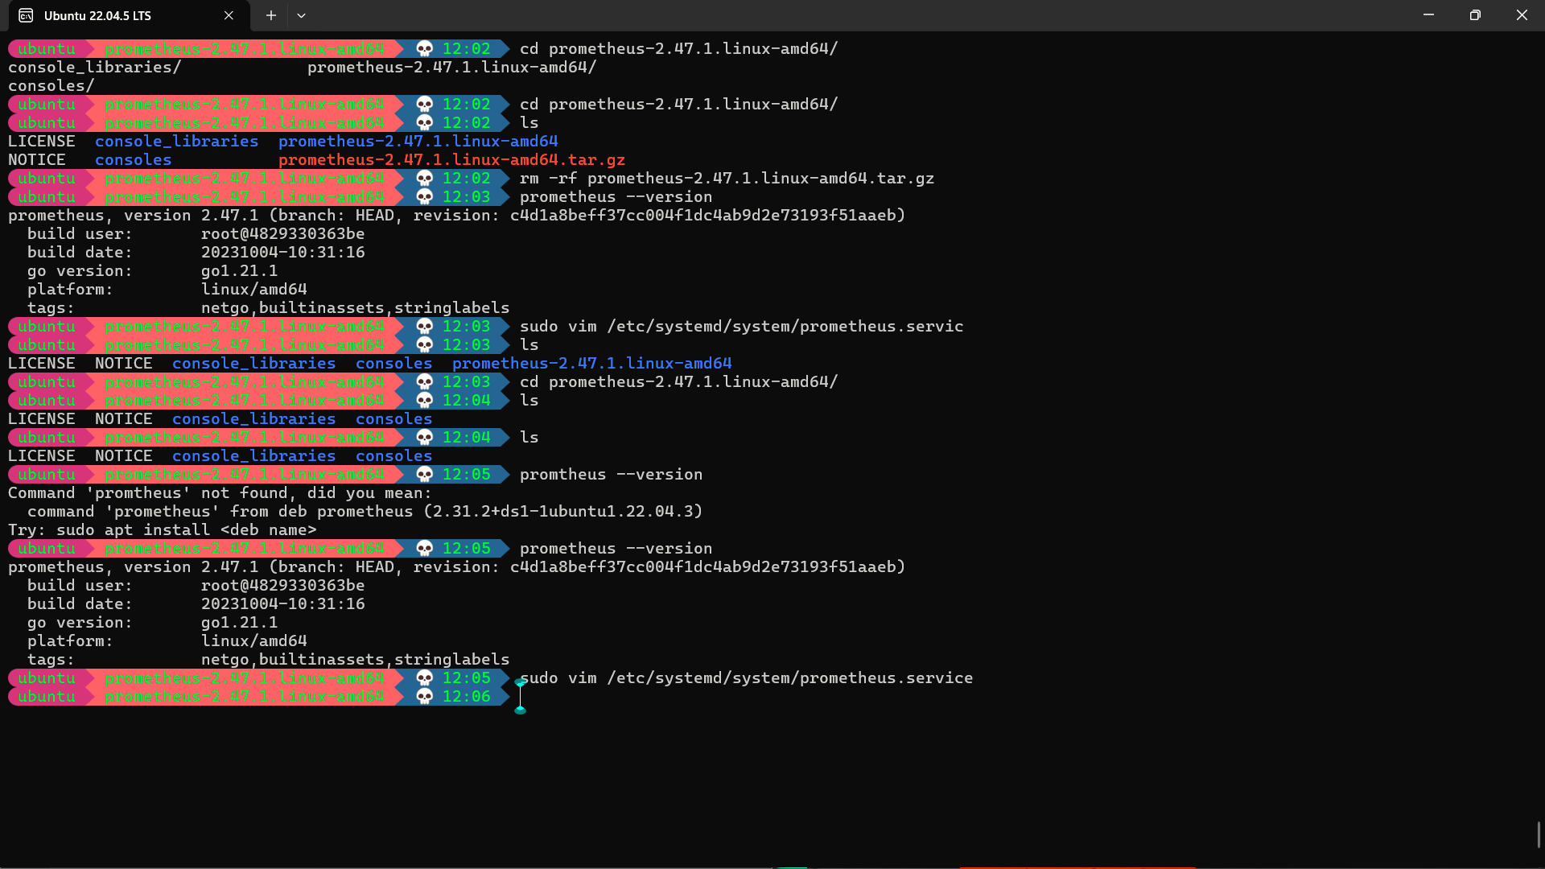

[Unit]
Description=Prometheus
Wants=network-online.target
After=network-online.target
StartLimitIntervalSec=500
StartLimitBurst=5
[Service]
User=prometheus
Group=prometheus
Type=simple
Restart=on-failure
RestartSec=5s
ExecStart=/usr/local/bin/prometheus \
--config.file=/etc/prometheus/prometheus.yml \
--storage.tsdb.path=/data \
--web.console.templates=/etc/prometheus/consoles \
--web.console.libraries=/etc/prometheus/console_libraries \
--web.listen-address=0.0.0.0:9090 \
--web.enable-lifecycle
[Install]
WantedBy=multi-user.target

sudo systemctl enable prometheus
sudo systemctl start prometheus
sudo systemctl status prometheus
journalctl -u prometheus -f --no-pager

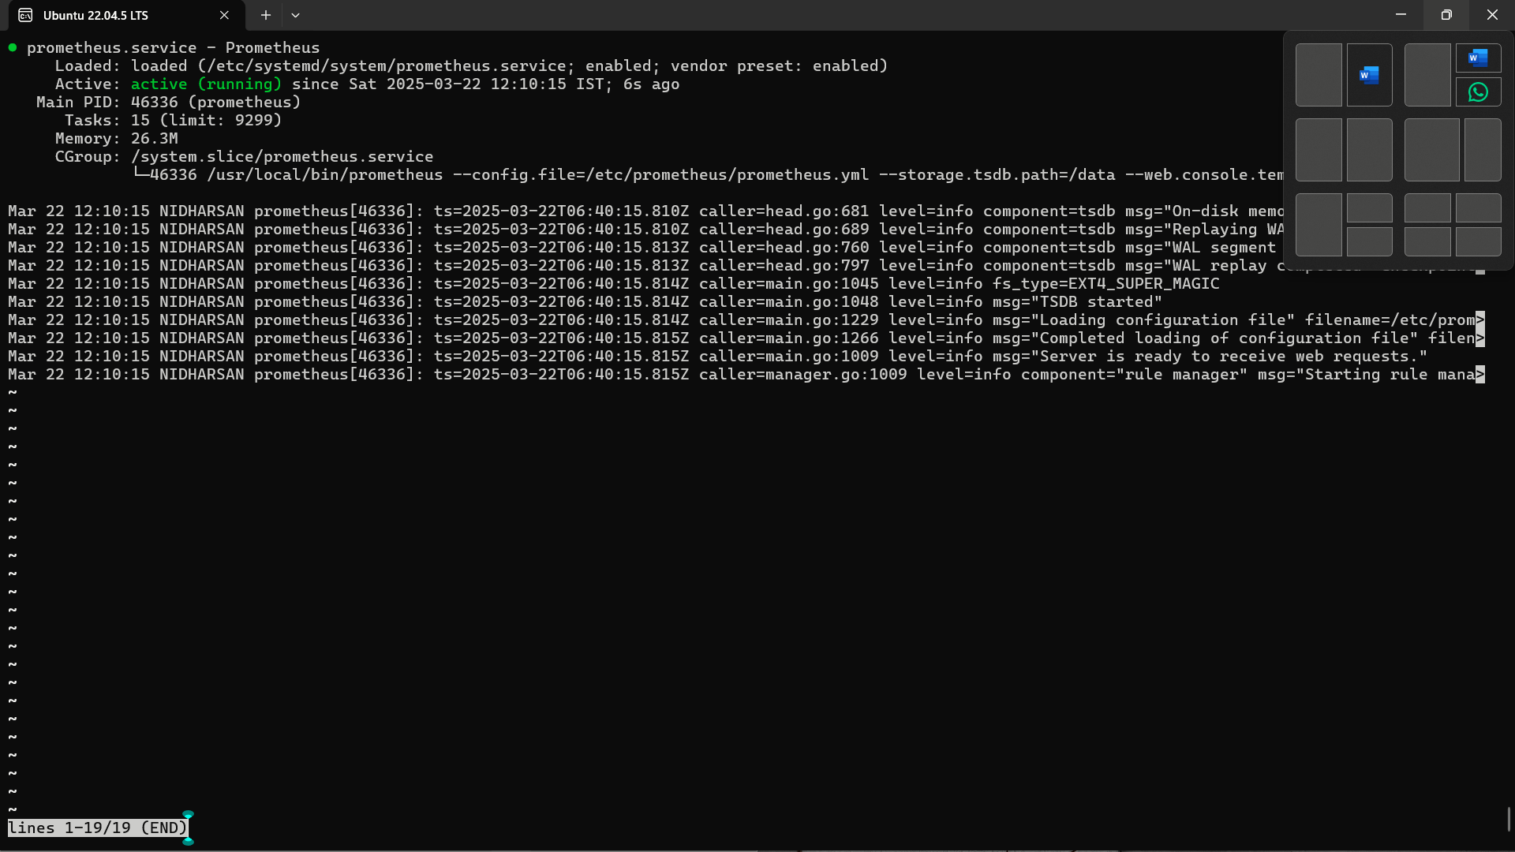

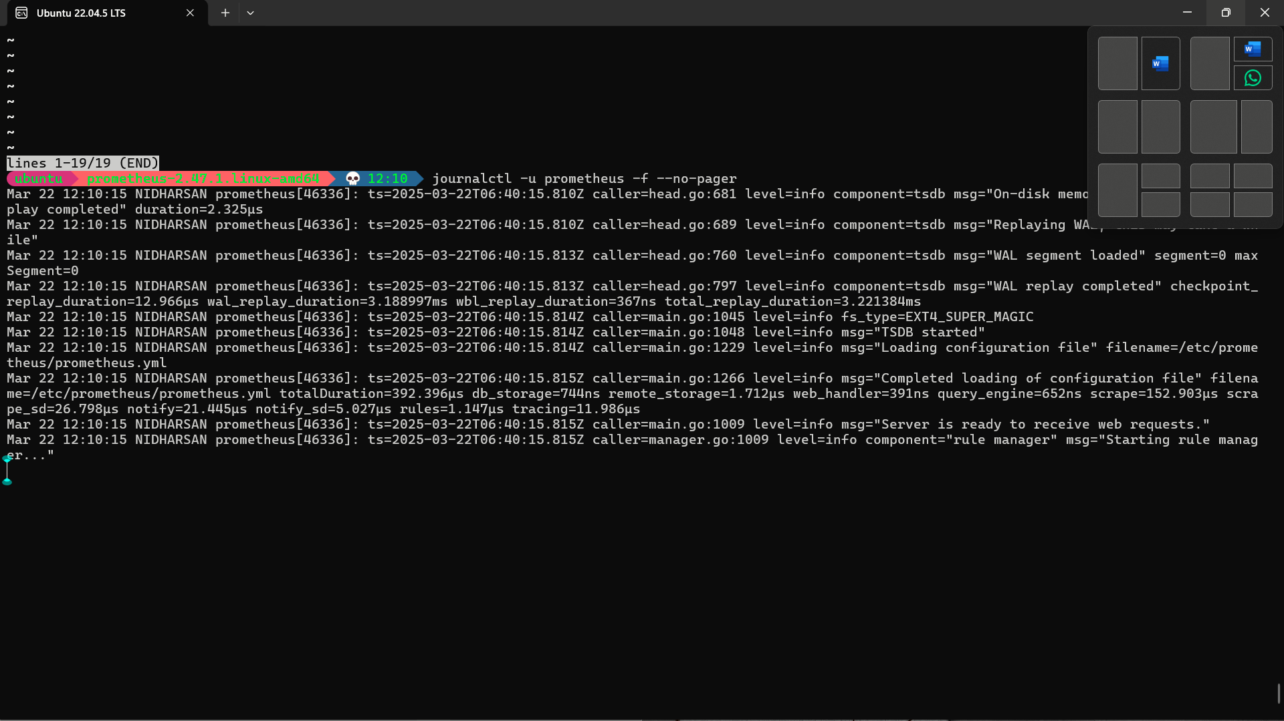

Node Exporter:

sudo useradd \
--system \
--no-create-home \
--shell /bin/false node_exporter

wget https://github.com/prometheus/node_exporter/releases/download/v1.6.1/node_exporter-1.6.1.linux-amd64.tar.gz
tar -xvf node_exporter-1.6.1.linux-amd64.tar.gz

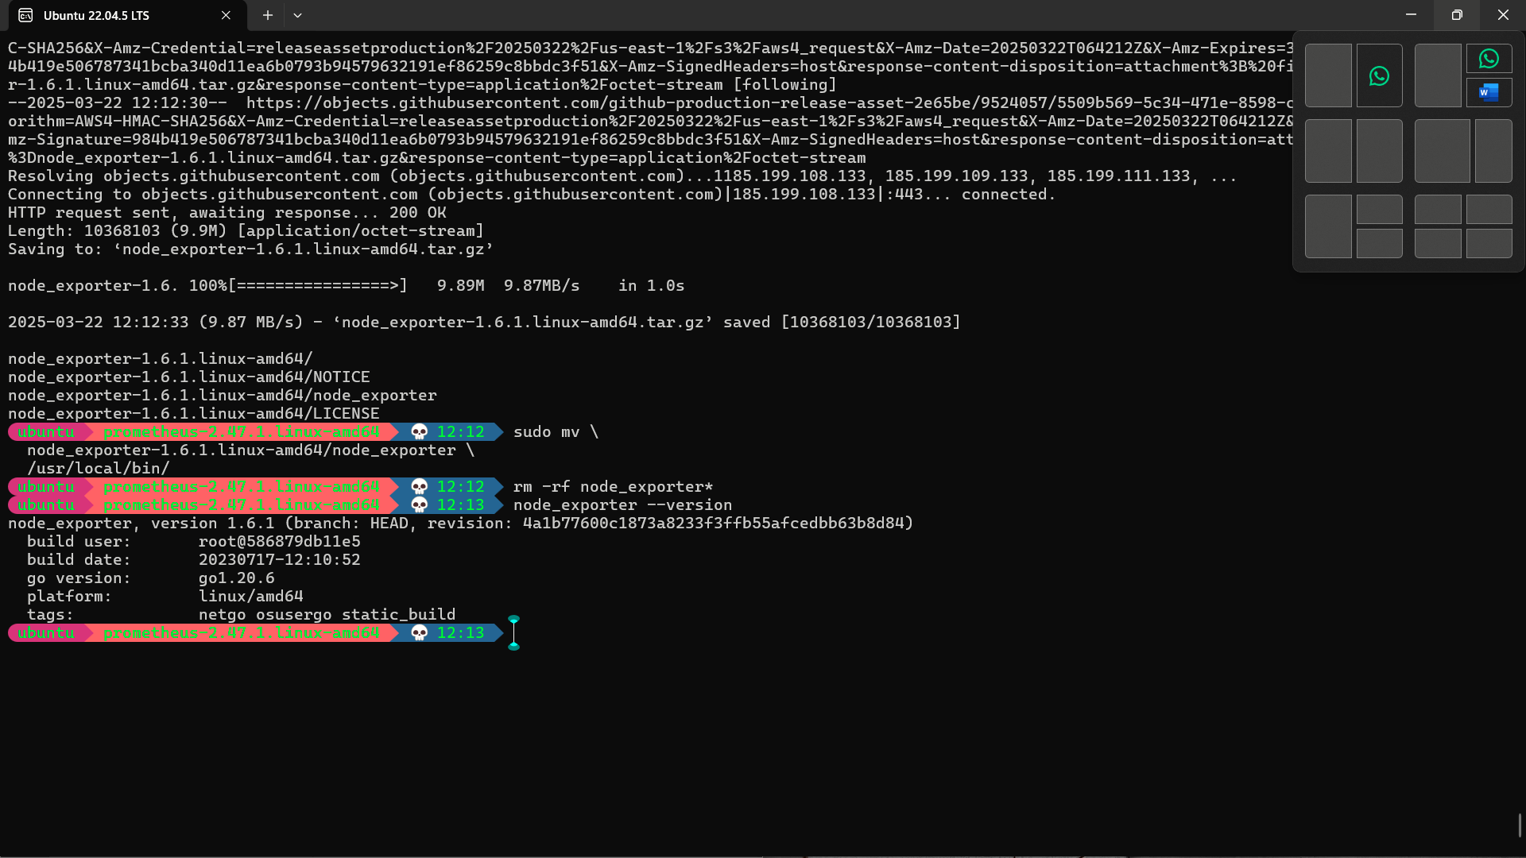

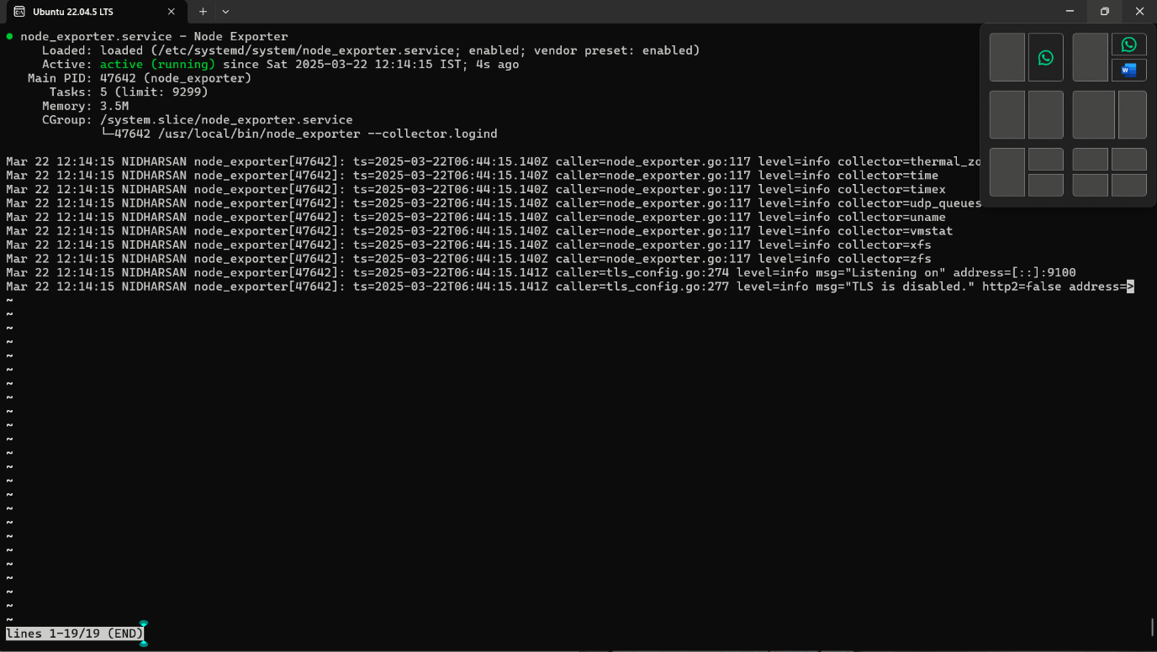

sudo vim /etc/prometheus/prometheus.yml

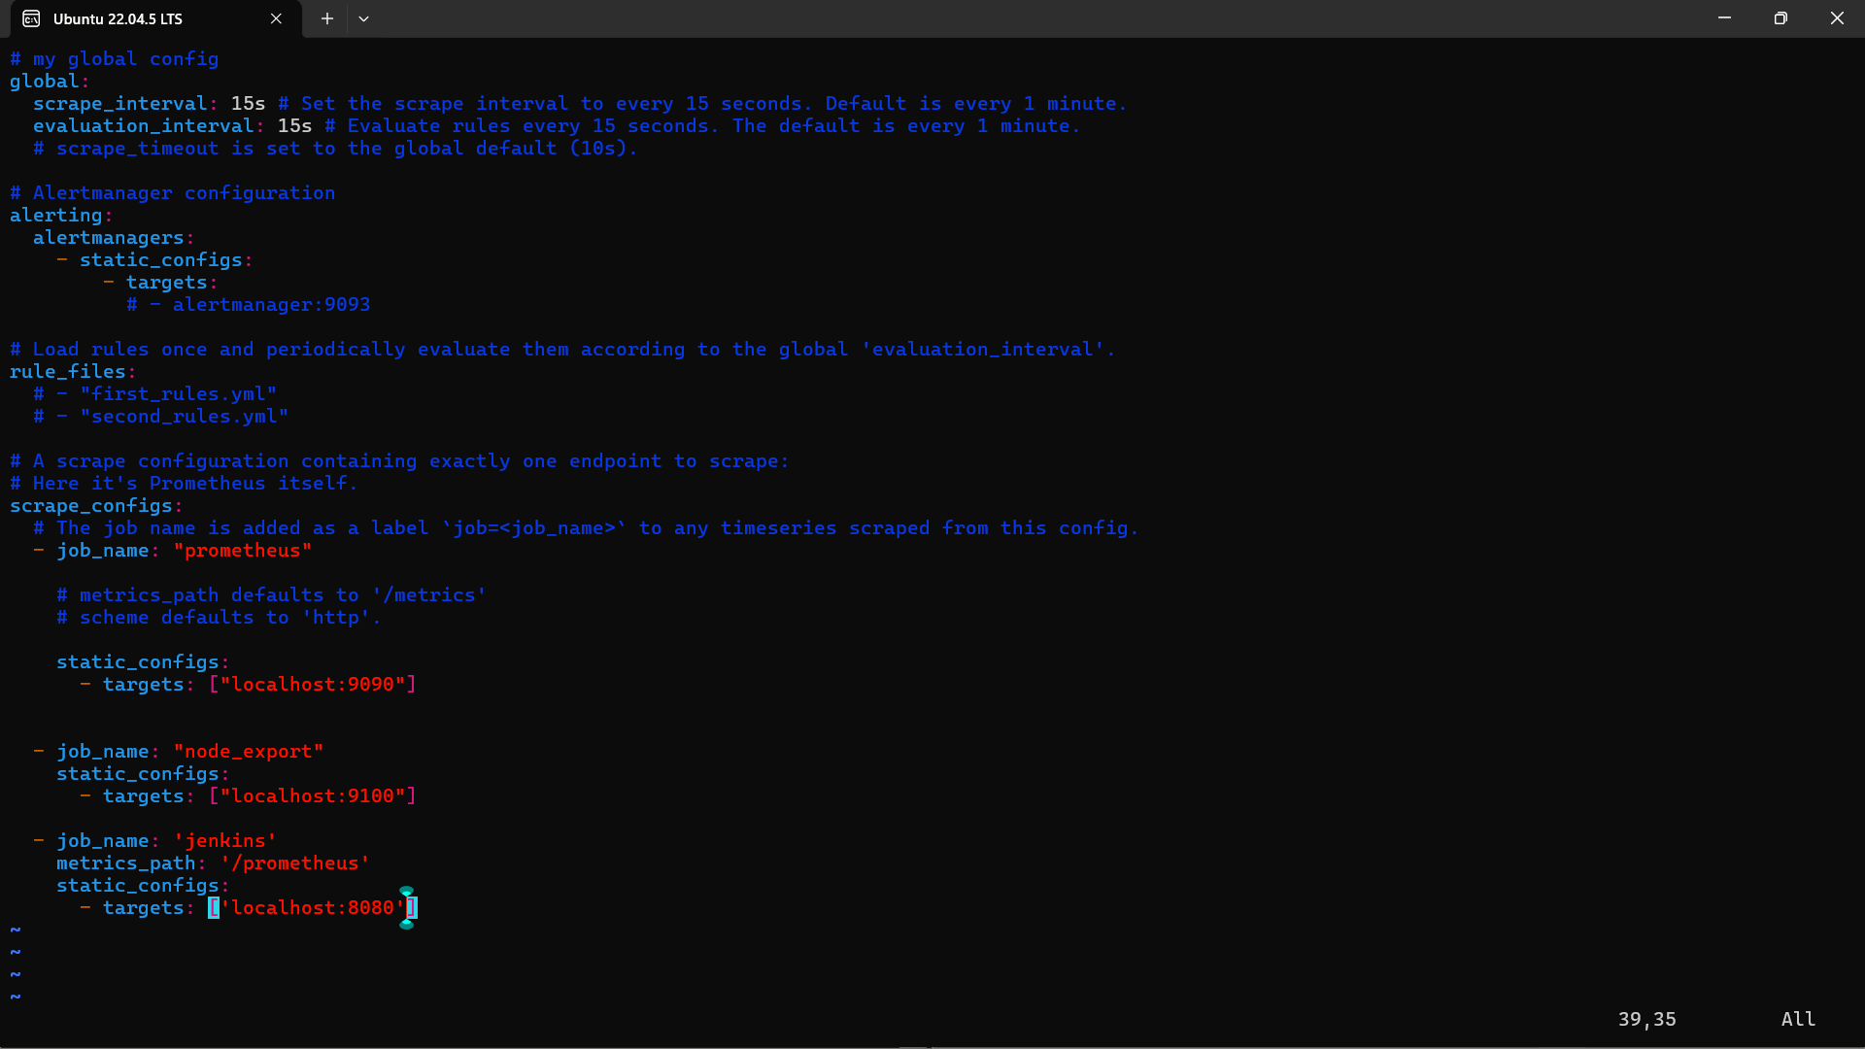

promtool check config /etc/prometheus/prometheus.yml

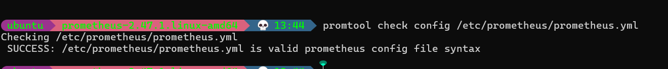

Grafana :

sudo apt-get install -y apt-transport-https software-properties-common
wget -q -O - https://packages.grafana.com/gpg.key | sudo apt-key add -
echo "deb https://packages.grafana.com/oss/deb stable main" | sudo tee -a /etc/apt/sources.list.d/grafana.list
sudo apt-get update
sudo apt-get -y install grafana
sudo systemctl enable grafana-server
sudo systemctl start grafana-server
sudo systemctl status grafana-server

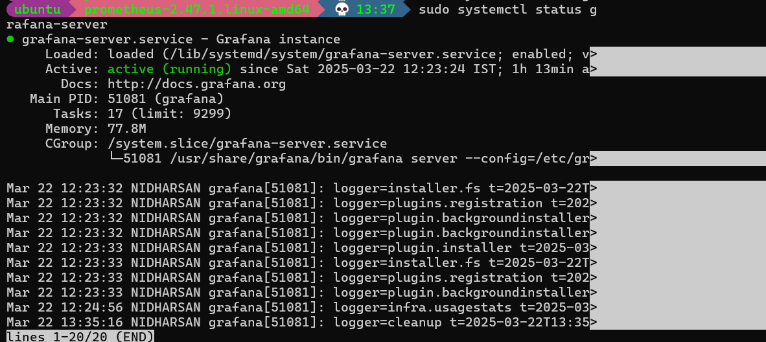

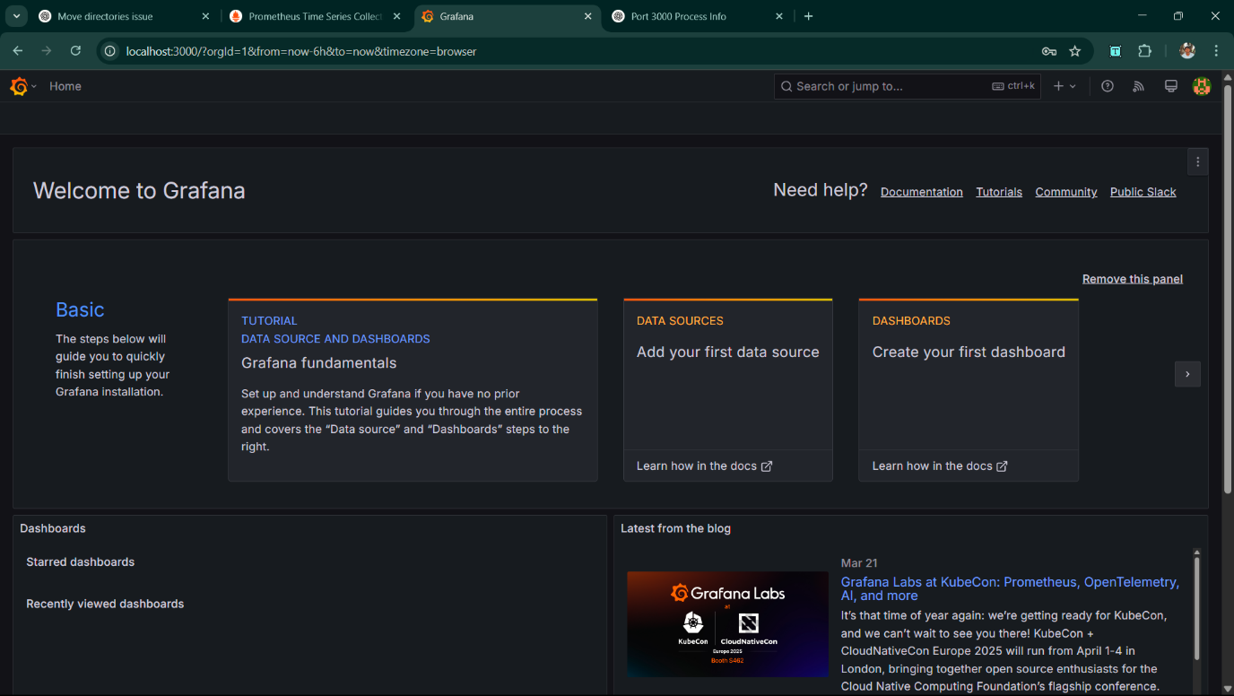

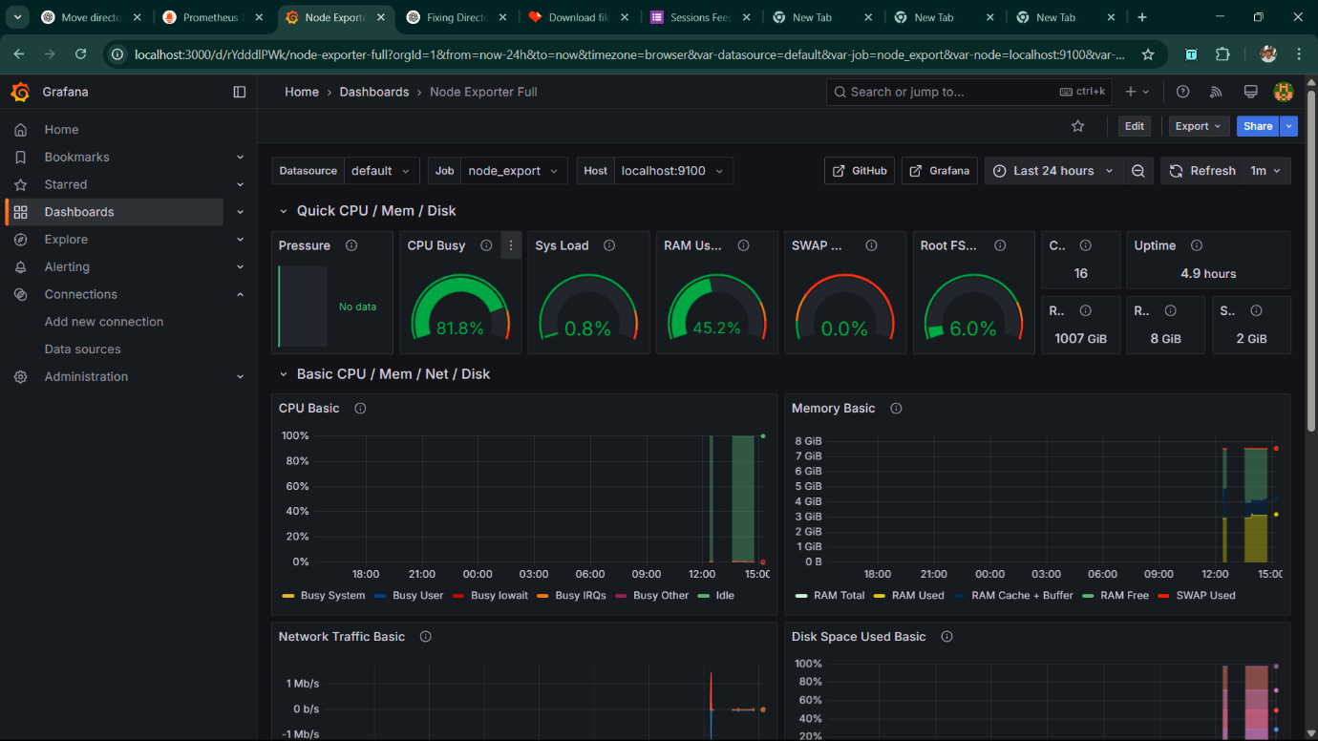

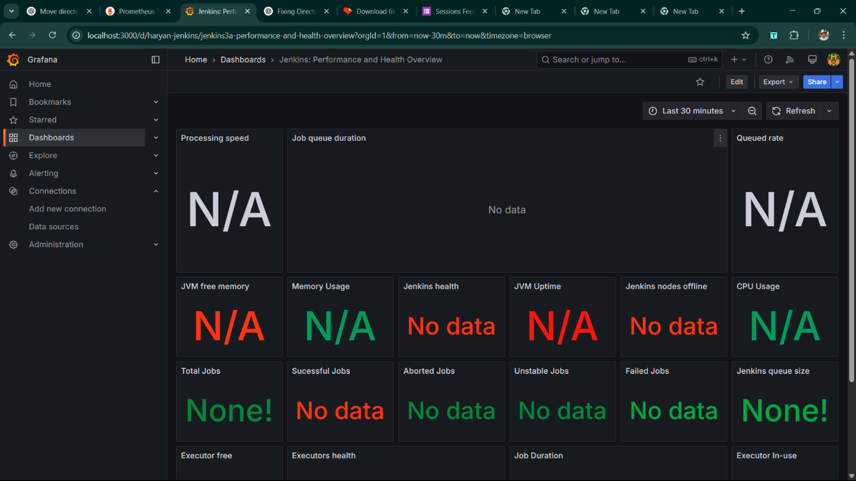

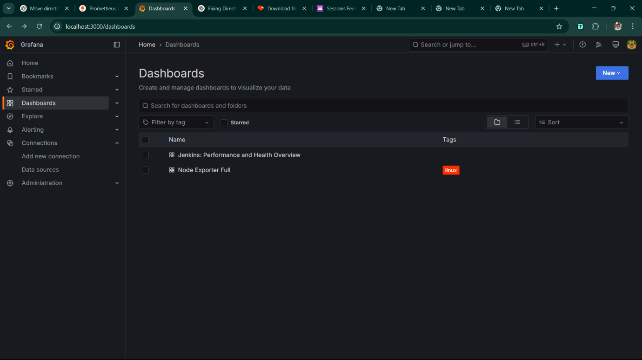

Metrics Running and Verifying:

- http://localhost:9090/metrics

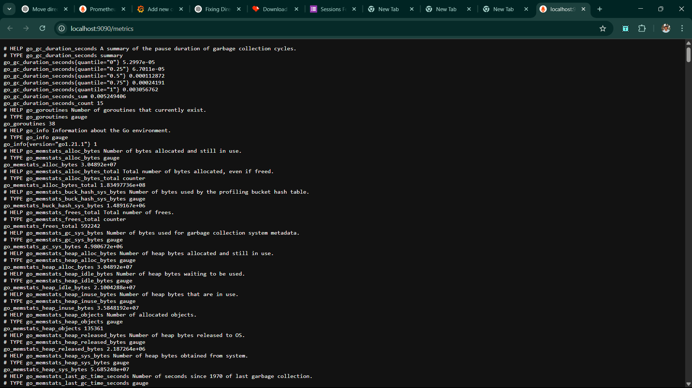

rate(node_cpu_seconds_total{mode="system"}[1m])

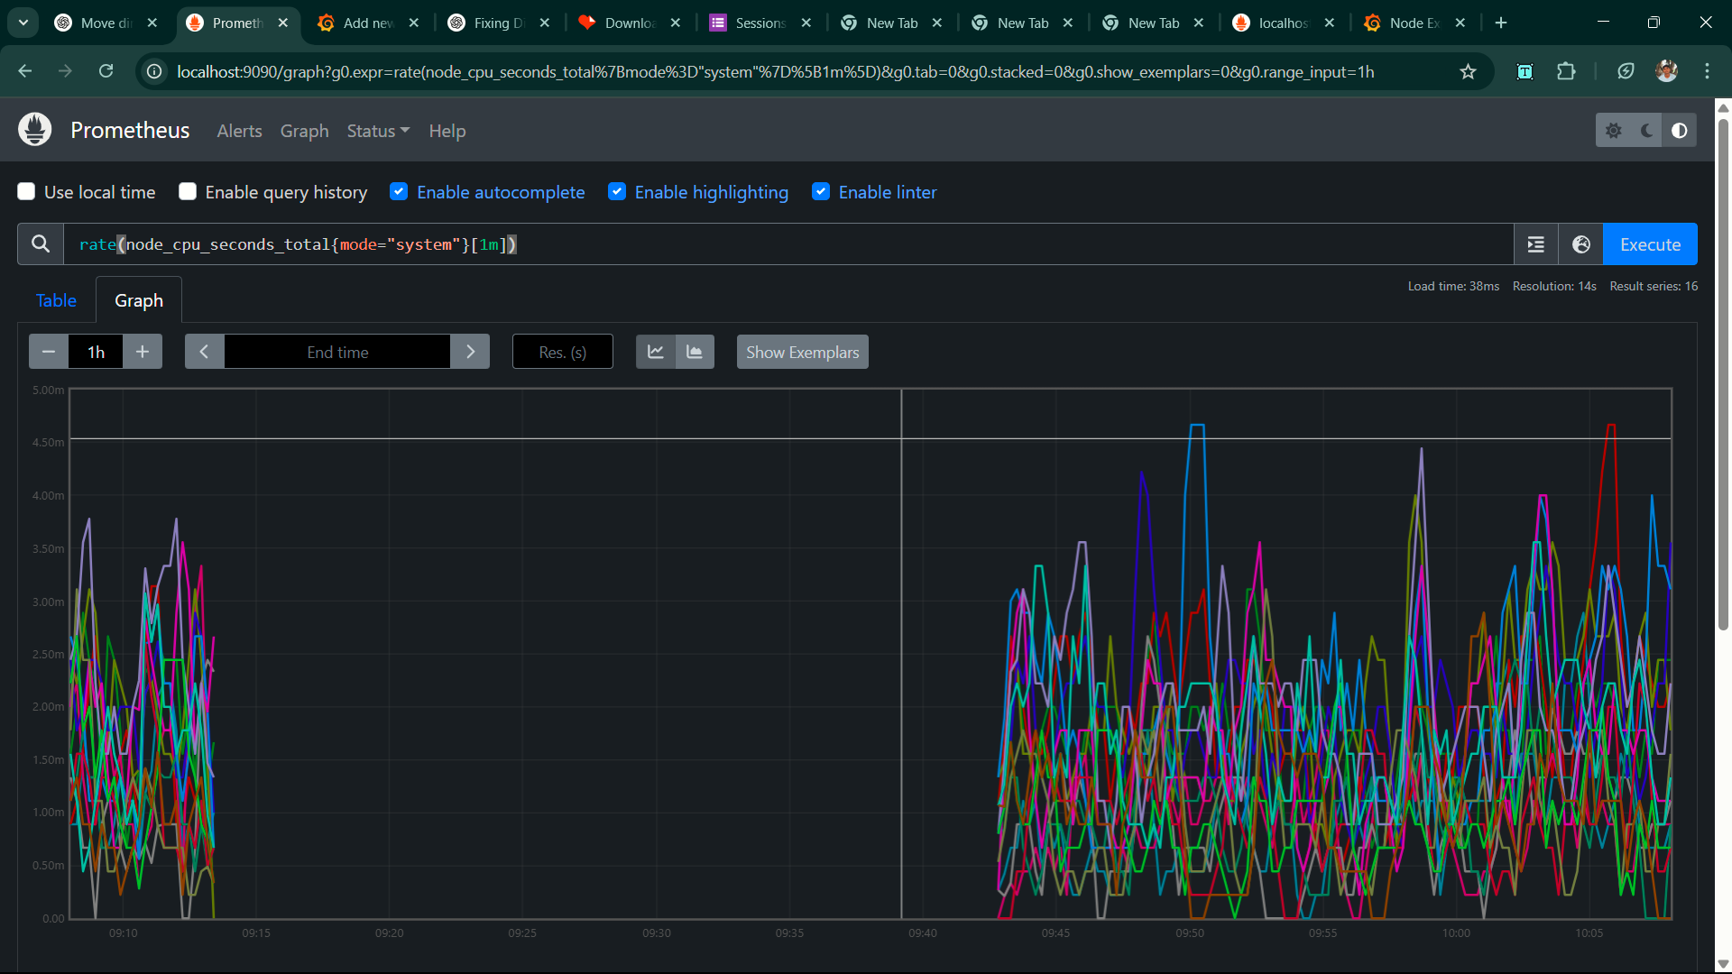

rate(node_network_receive_bytes_total[1m])

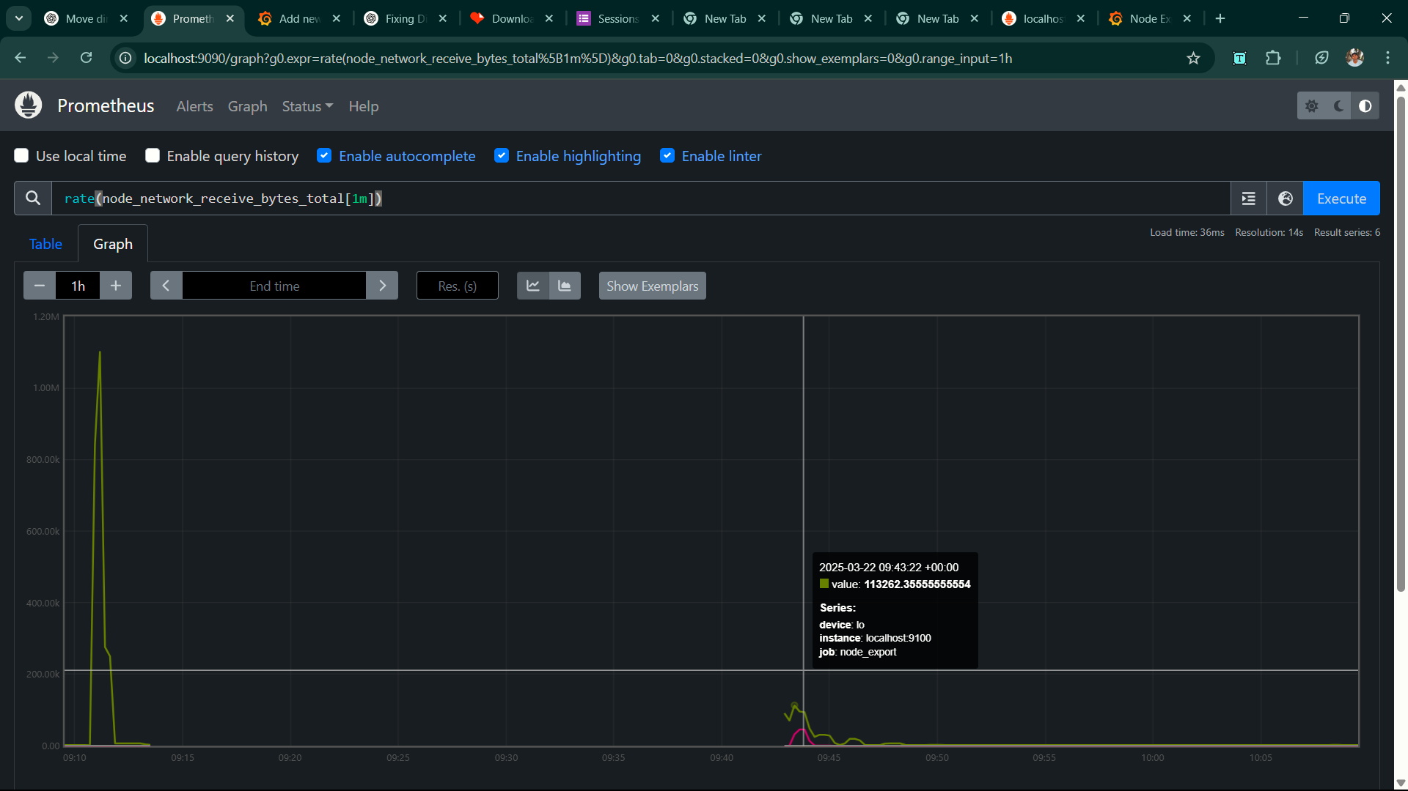

node_load15

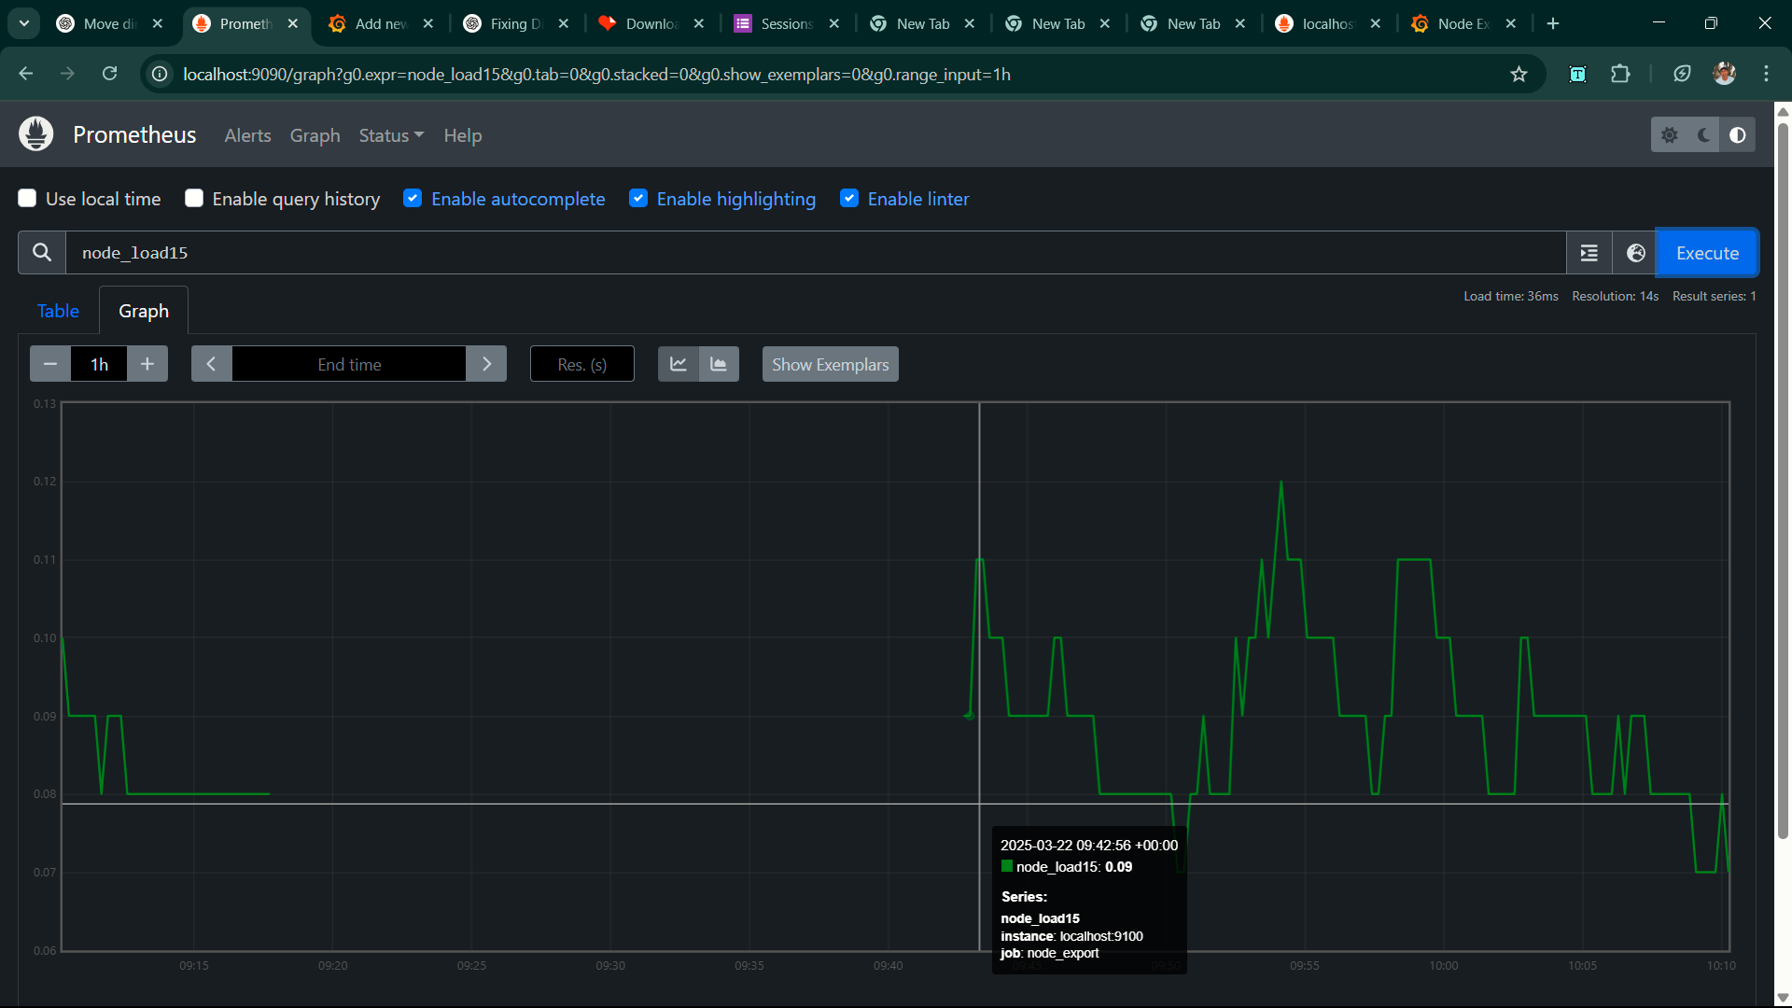

DashBoards:

https://grafana.com/dashboards/405

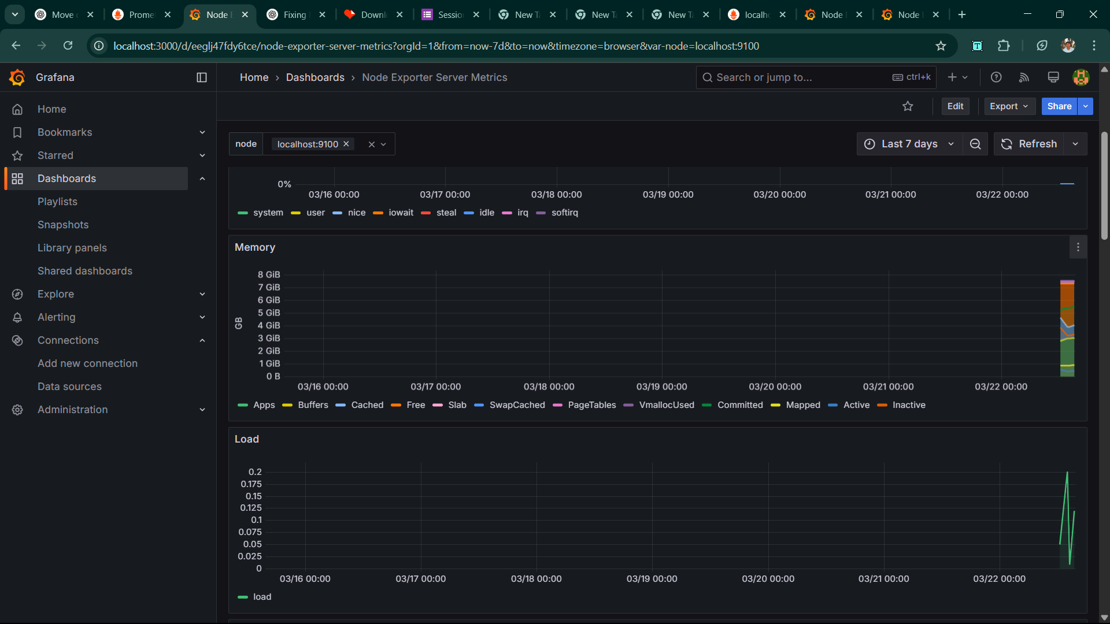

https://grafana.com/dashboards/1860

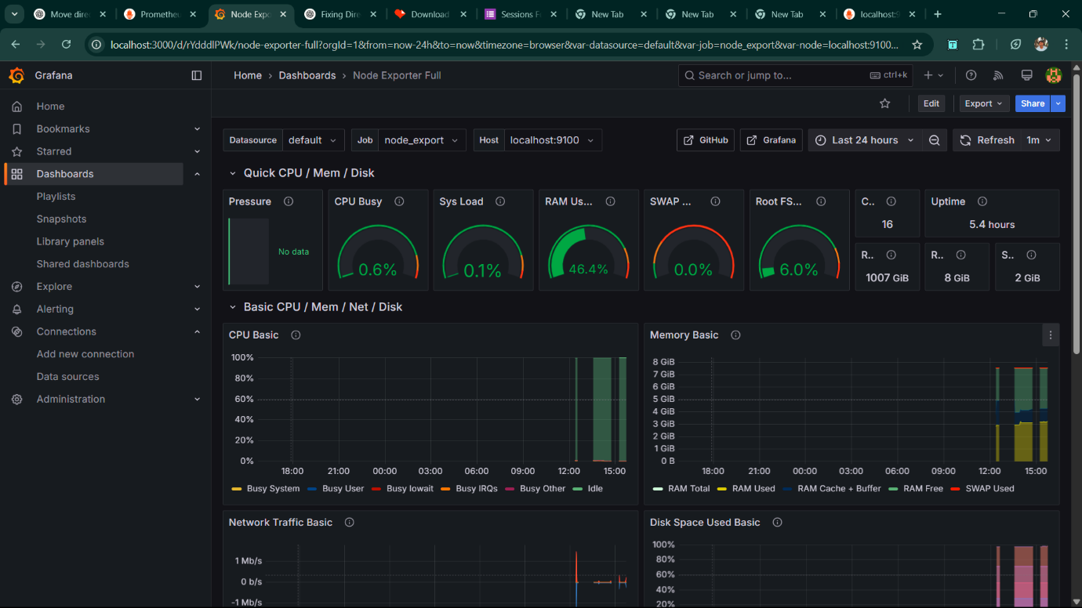

https://grafana.com/dashboards/5174

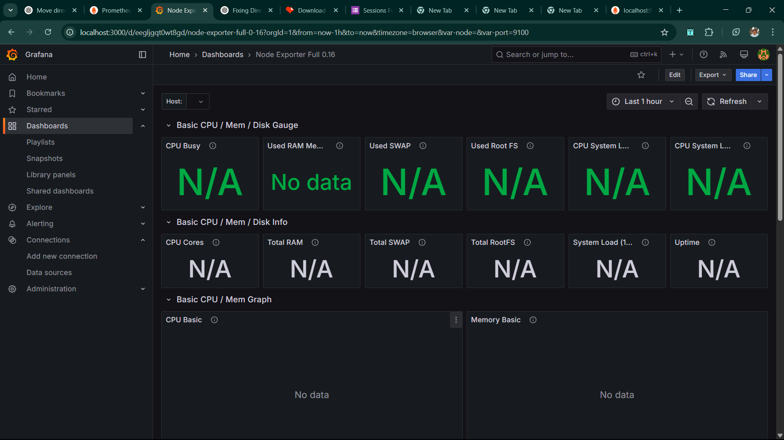

https://grafana.com/dashboards/9096

